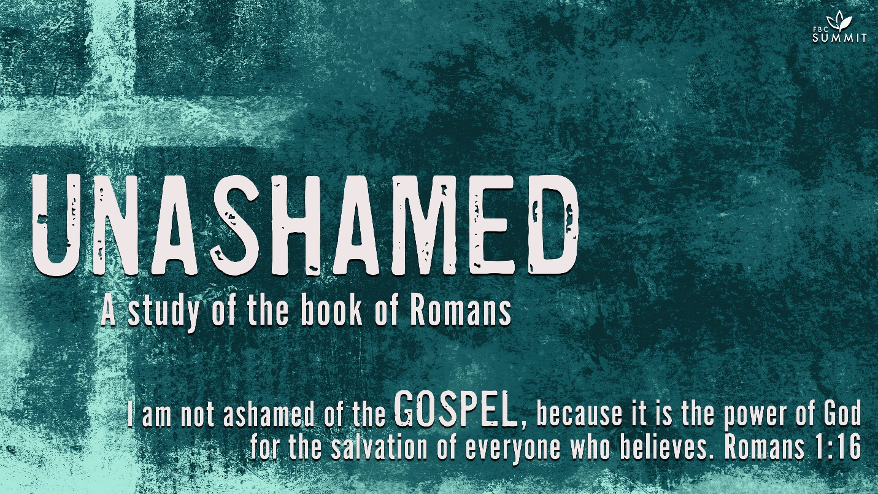

January 17, 2021
Romans 1:8-17

⁸ First, I thank my God through Jesus Christ for all of you, because your faith is being reported all over the world. ⁹ God, whom I serve in my spirit in preaching the gospel of his Son, is my witness how constantly I remember you ¹⁰ in my prayers at all times; and I pray that now at last by God’s will the way may be opened for me to come to you.

¹¹ I long to see you so that I may impart to you some spiritual gift to make you strong— ¹² that is, that you and I may be mutually encouraged by each other’s faith. ¹³ I do not want you to be unaware, brothers and sisters,^{[a]} that I planned many times to come to you (but have been prevented from doing so until now) in order that I might have a harvest among you, just as I have had among the other Gentiles.

¹⁴ I am obligated both to Greeks and non-Greeks, both to the wise and the foolish. ¹⁵ That is why I am so eager to preach the gospel also to you who are in Rome.

¹⁶ For I am not ashamed of the gospel, because it is the power of God that brings salvation to everyone who believes: first to the Jew, then to the Gentile. ¹⁷ For in the gospel the righteousness of God is revealed—a righteousness that is by faith from first to last,^{[b]} just as it is written: “The righteous will live by faith.”

COMMENTARY
1:8. It was common in ancient letters to begin with a prayer. Paul adopted the form, but his prayers were never just formal. As there is joy among the angels at the conversion of one sinner (Lk 15:10), Paul rejoiced over the fact there were house churches in the capital city of the Roman Empire. He was thankful for the spread of the faith.

1:9-10. Paul continually prayed for the Roman Christians in his spirit. Though too often perceived as otherwise, prayer is just as necessary as teaching or preaching in Christian ministry. Paul had wanted to come to Rome, but God was in control of all his circumstances. The believer must seek God’s will in his activities (Jms 4:13-17).

1:11-12. Paul was certain he would bring certain benefits or blessings as he taught among the house churches of Rome. The spiritual gift mentioned here was not the special gift(s) in 1Co 12-14 which were given by God (1Co 12:11) but gifts that Christians gave to one another. Paul was certain that the Roman Christians would minister to him since every part of the body of Christ has useful functions in relation to other parts (1Co 12:12-27).

1:13. How is it that the most important city in the world had not yet had a visit from an apostle? Why especially had the “apostle to the Gentiles” not come? Paul often planned to come, but these plans had not come to fruition. In the mysterious providence of God it all worked out for the best. After all, Paul’s delay in fulfilling his trip to Rome caused him to write this wonderful letter. Furthermore, he eventually went to Rome as a prisoner (Ac 25:10-28:14-16), spending two years in the city preaching the gospel “without hindrance” (Ac 28:31). Believers must learn that God works out events in ways we could never imagine (Rm 8:28).

1:14. Paul’s conversion placed a special commission and obligation on him (Ac 9:15; 13:47; 1Co 9:16; Gal 2:8-9). The revelations granted to him gave him greater responsibility. His training and Roman citizenship equipped him to reach all varieties of pagans, including the educated and the barbarians. These barbarians included people from Spain and Asia Minor (Ac 14:11-18).

1:15. Paul was eager to fulfill his obligation because he expected God to do great things through his ministry.

1:16. Why might someone be ashamed of the gospel? On the surface, the gospel seems like a very strange message. It is about a Jewish carpenter and teacher who was put to death on a cross by Pontius Pilate, Roman governor of Judea in a.d. 26-36. The message says that this man Jesus was raised from the dead and is now Lord—the kurios. This title was used of God in the Greek Bible and was applied to the emperor by some Romans. Paul himself wrote that this message seemed foolish to Gentiles (1Co 1:23) and was a stumbling block to Jews. A crucified Messiah seemed to be a contradiction in terms to the Jews. A crucified Jew seemed like foolishness to the Romans, who despised Jews in general. Anyone who was crucified was considered among the lowest members of society. Paul had no confidence in his rhetorical skills to overcome the human objections to the message, but he knew the power of the Spirit to change the lives of people as they heard the good news about Jesus’ death and resurrection. People are saved by faith, but faith is not the cause of salvation. The cause of salvation is the grace of God, the will of God, and the Spirit’s power working through the message.

1:17. God’s righteousness was the core of Paul’s message. Luther came to better understand God’s grace as he studied this verse in the original Greek rather than in the Latin translation. It forever changed his view of God. God’s righteousness can be understood in several ways. First, God always does what is right and can be said to have righteousness as one of His attributes (Dt 32:4; Ps 119:142). Second, since God always does what is right, His actions or activities are sometimes identified as His righteousness (Isa 45:8; 46:13; 51:5-6,8; 56:1). Third, God’s righteousness is as a gift from Him to us, justifying us in His sight. “Justification” is a courtroom term signifying that a judge declares a person to be “right” or “just.” Augustine wrote “the righteousness of God is that righteousness which He imparts in order to make men righteous” (Spirit and the Letter, chap. 16). In the gospel, God reveals His righteousness (His nature, His activity, and His gift of right status) by faith. In the course of this letter, Paul will explain how God is able to declare sinners to be righteous because of Jesus’ work on the cross. From faith to faith emphasizes that the entire process of being declared righteous comes to us from start to finish by faith.

MAIN POINT
As God’s people, we are called to leverage our lives for Jesus Christ and His church.

INTRODUCTION
As your group time begins, use this section to introduce the topic of discussion.

In one sentence, how would you describe your life purpose? What are you willing to do or sacrifice to live out that out?

Of all the people, causes or movements you are passionate about, which do you most desire to live for? Which would you be most willing to die for?

Romans 1:8-17 continues the breathtaking introduction by the apostle Paul to a church he had never visited. Before going to Rome, Paul wrote to share His life calling and to proclaim the good news of the gospel—a message built on the foundation of God’s revelation in the Hebrew Scriptures of Israel, and fulfilled in the Person and work of Jesus Christ. Paul is identified by his commitment—to God’s calling, to people and to the gospel, stewarding his entire life for the furthering of God’s kingdom and purposes through the Roman people and throughout the earth.

UNDERSTANDING
Unpack the biblical text to discover what the Scripture says or means about a particular topic.

- HAVE A VOLUNTEER READ ROMANS 1:8-15

Word of the Roman Christians’ faith spread throughout the ancient world. How can we steward our resources, time, and talents to the work and relationships that help other people see Christ?

How do we “serve with [our] spirit in the gospel of His son” (v. 9)?

How do we mutually encourage one another with our faith (v. 12)?

In what way can that utilize our unique talents to impart a spiritual gift that strengthens others (v. 11)?

What does it mean to reap a harvest among others (v. 13)? Is this a harvest we should seek in this world, or the next?

As a servant who is called and set apart (v. 1), Paul was under obligation not only to God but also to those who would hear the message. Paul’s sense of obligation to carry the message of Christ was not a burden. To the contrary, he was “eager to preach” to those who were in Rome.

- HAVE A VOLUNTEER READ ROMANS 1:16-17.

According to these two verses, what is the great news of the gospel that we tell?

There was no lack of philosophies in Paul’s day to capture people’s interest. Some of these belief systems took seriously the matter of trying to live a so-called virtuous life. However, the gospel message that Paul preached did not center around self-improvement through stringent self-discipline. Rather, the good news was about putting one’s faith in a unique Person—Jesus Christ. God’s grace alone can save, and is the best and only pure motive for eternal good deeds, and the proclamation of His gospel to others.

When you think of God’s power, what do you normally think of?

How is the gospel a display of God’s power?

Where might we be today if Paul had been ashamed of the gospel? Why might we be ashamed of the gospel?
What are you afraid of losing in proclaiming the Gospel to others? Is it more valuable than the eternal salvation of those you love?

From Romans 1:16-17, what can you conclude is the purpose of our lives as believers? How does this change the way God calls us to steward our resources, time, and talents?

When we think of God’s power, we might think of creation, or of God parting the Red Sea, or maybe God’s power to heal the sick. The gospel is the power of God to salvation, and in it, we see God’s power to cancel sin, to defeat death, and to make sinners sons and daughters of God. That is God’s amazing power!

We need not be afraid to share the gospel because it is true. Jesus has triumphed over sin. Jesus has triumphed over the grave. Jesus is at the right hand of the Father interceding for us right now. God will vindicate our faith in the last day, and He will bless our testimonies now to bring others to Jesus.

NEXT STEPS
Help your group identify how the truths from the Scripture passage apply directly to their lives.

What would be the identifying characteristics of a church for which the stewardship and spread of the gospel were the top priorities?

Since the gospel is good news, can you think of all the goodness and joy it has brought in your life? Can you, from that joy, share the good news with others?

If the gospel is indeed “the power of God,” how should that power be demonstrated among those who have embraced the gospel message? What should be the evident distinctions from those who have not?

As believers, we often view personal evangelism as a daunting and forced task, for which we are under-prepared and unqualified. In reality, how can this become a natural part of everyday life?

Consider the person or people who first shared Christ with you. What about your relationship or conversation with them persuaded you to trust and listen to them?
PRAYER
Close your small group time in prayer. Lead your group to pray for the faith to believe that the news of the gospel is as good as it is, and that the eternal work and rewards of that gospel—in our lives and those of others—are more valuable than anything we might lose in our efforts to make it known. Pray that the goodness and urgency of this message will compel us to faithfully, joyfully, and selflessly proclaim it by stewarding our resources, time, talent, and very lives to making it known.

