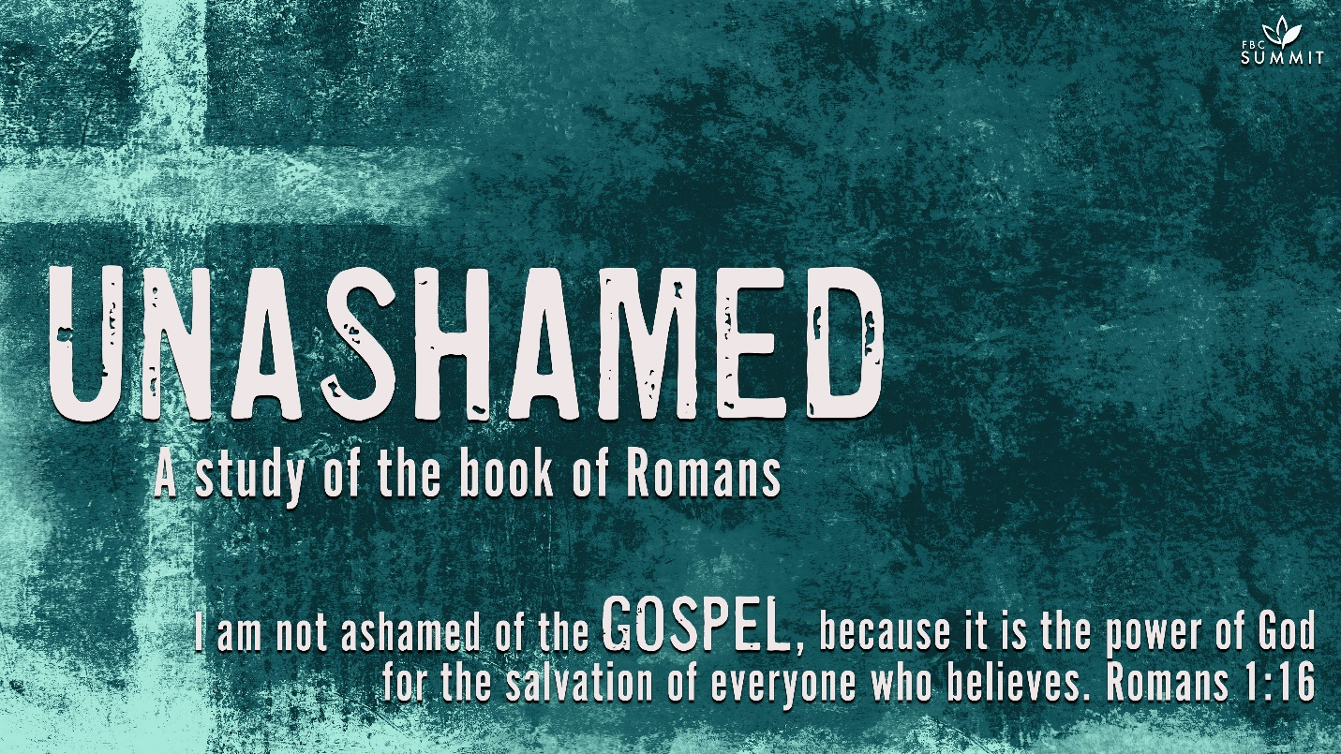

January 24, 2021
Romans 1:18-23

¹⁸ The wrath of God is being revealed from heaven against all the godlessness and wickedness of people, who suppress the truth by their wickedness, ¹⁹ since what may be known about God is plain to them, because God has made it plain to them. ²⁰ For since the creation of the world God’s invisible qualities—his eternal power and divine nature—have been clearly seen, being understood from what has been made, so that people are without excuse.

²¹ For although they knew God, they neither glorified him as God nor gave thanks to him, but their thinking became futile and their foolish hearts were darkened. ²² Although they claimed to be wise, they became fools ²³ and exchanged the glory of the immortal God for images made to look like a mortal human being and birds and animals and reptiles.

COMMENTARY
1:18. All people need the gospel because they are under God’s wrath, which stems from His holy revulsion to sin. Paul wrote this letter from the Greek city of Corinth—a city full of idolatry and immorality. Mankind originally knew God and fellowshipped with Him (Gen 3:8a). The history of the world and of the OT reveals a subsequent regression and loss of moral knowledge. Since the garden of Eden, people have been unrighteous, and they have suppressed the truth.

1:19. God as Creator has disclosed Himself in creation. “The heavens declare the glory of God, and the sky proclaims the work of His hands” (Ps. 19:1). People also have an innate capacity for God as well as a moral conscience. God is at work to show Himself in the world, yet the world is in rebellion against Him.

1:20-21. Mankind’s problem isn’t that he doesn’t know the truth. The history of the human race discloses a determined effort to oppose the will of God. People are without excuse for their idolatry and practical atheism. Because of human willfulness, people’s knowledge of God became clouded and their thinking became darkened. Without contact with God, the center of man loses contact with reality, misses the purpose of his existence and becomes ungrateful. People are supposed to glorify Him as God, but instead find all sorts of created objects to worship. Part of the wrath of God is revealed in humanity’s loss of intelligent thinking.

1:22. A classic example of human foolishness is found in Isa 44:9-20 where human cleverness ends in stupidity.

1:23. Many people think that the history of religion developed along an evolutionary model. In this view, humanity originally held animistic beliefs and then progressed to polytheism, to tribal deities, and then to a single creator God. From there we progressed to a vague philosophical monotheism in the Enlightenment, and finally we are now embracing atheism in the age of science. But this is not true to the early history of religion. Instead of starting in polytheism, the Bible says humanity started with knowledge of the one true God and then declined into polytheism as humans were separated from God and fractured from one another. Paul warns that loss of knowledge of the true God resulted in the worship of images resembling mortal man. Even in the modern age we have seen dictators worshiped as god, and the Bible says this sin will be repeated climactically in the end times (see 2 Thes. 2:3-12; Rev. 13:1-18).

MAIN POINT
All people are without excuse.

INTRODUCTION
As your group time begins, use this section to introduce the topic of discussion.

What makes you say, “That’s not fair”?

What emotions do you experience when you’re accused of being unfair?

The study we are about to experience together will help us understand how God relates to people who have never heard the gospel. The Book of Romans is Paul’s orderly explanation of the gospel. Romans could be described as a treatise on the doctrine of salvation. He began by showing that all of us are in need of this salvation because we are all sinners. None of us is without excuse, for even the world around us points us to God.

UNDERSTANDING
Unpack the biblical text to discover what the Scripture says or means about a particular topic.

God loves us so much that whenever He sees someone who truly wants to know Him, He’ll send the gospel. There are two examples of this—the Ethiopian eunuch (see Acts 8) and Cornelius (see Acts 10). “The Lord does not delay His promise, as some understand delay, but is patient with you, not wanting any to perish but all to come to repentance” (2 Pet. 3:9). God isn’t trying to condemn as many people as possible, He is trying to save as many people as possible. Knowledge of God is available to everyone. “It is God’s power for salvation to everyone who believes, first to the Jew, and also to the Greek” (Rom. 1:16).

God not only ordained the end, but He ordained the means to the end, and that means us. Who has been instrumental in making sure you know about Jesus?

What do you see as your responsibility in making sure others know about Jesus?

- HAVE A VOLUNTEER READ ROMANS 1:18-23.

What’s your initial reaction to these verses? What questions do you have about these verses? What new application do you hope to get from this passage?

What does it mean that people are without excuse?

What are some situations in which people are “without excuse” in everyday life?

Is it fair that people go to hell even though they have not heard about Jesus? Explain.

How can we reconcile God’s desire for all people to be saved with the fact that all people have not heard about Jesus?

What emotions have you experienced so far during this discussion? Why?

How does the concept of faith apply to our discussion?

What questions or tensions from this discussion feel unresolved to you?

How can you move forward in your walk with God even if these questions or tensions remain unresolved?

God will deal with each person based on what they do with the revelation of who God is and what Jesus Christ has done.

NEXT STEPS
Help your group identify how the truths from the Scripture passage apply directly to their lives.

What keeps you from sharing your testimony with others?

With whom can you share the gospel this week?

Would you consider going on a short-term mission trip? Why or why not?

PRAYER
Close your small group time in prayer. Ask for prayer requests and ask group members to pray for the different requests as intercessors. As the leader, close this time by asking the Lord to help each of you do your part in making sure those who have never heard the good news of Jesus Christ hear this message soon.

