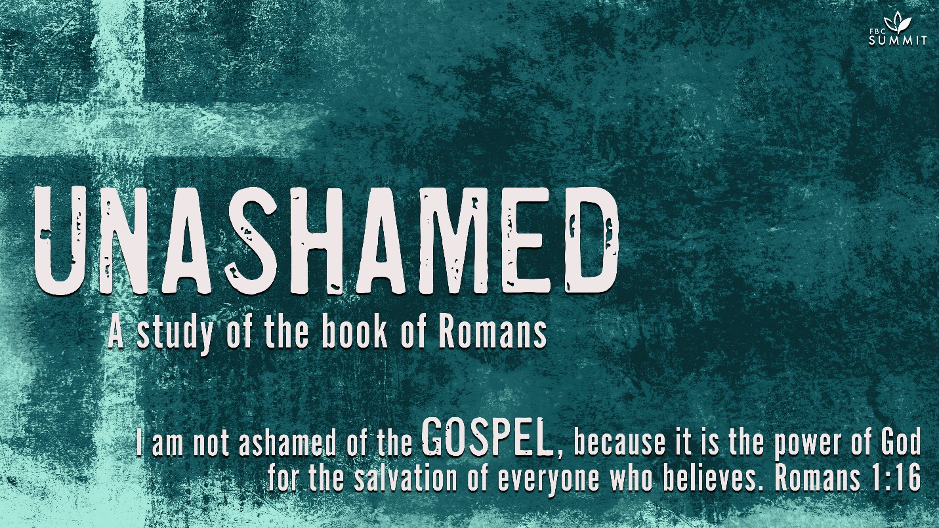

January 31, 2021
Romans 1:24-27

²⁴ Therefore God gave them over in the sinful desires of their hearts to sexual impurity for the degrading of their bodies with one another. ²⁵ They exchanged the truth about God for a lie, and worshiped and served created things rather than the Creator—who is forever praised. Amen.

²⁶ Because of this, God gave them over to shameful lusts. Even their women exchanged natural sexual relations for unnatural ones. ²⁷ In the same way the men also abandoned natural relations with women and were inflamed with lust for one another. Men committed shameful acts with other men, and received in themselves the due penalty for their error.

COMMENTARY
1:24. God is not ambiguous in His response to man’s rejection of Him and/or replacing Him with graven images (Ex. 20:3-4). In addition to passing eternal judgment on sin, He also addresses sin in our present world. Concerning people who persist in their rejection of God, Paul said God delivered them over in the cravings of their hearts to live according to the sins they loved, including sexual impurity. Consequently, their bodies are degraded among themselves. Delivered over shows that one way God pours out His wrath on sin is by removing His restraint and allowing sinners to reap the fruit of their spiritual rebellion. Consequently, God’s wrath both responds to sin and opens the way for it to flourish as He allows hardened sinners to follow their godless desires (Ps. 81:11-12).

1:25. Paul addressed one of the foundational errors of unbelievers: they have exchanged the truth of God for a lie. (Literally, “the” lie. Idolatry is not just one sin among many; it is the sin that causes people to worship something or someone that is not God.) Consequently, unbelievers have worshiped and served something created instead of the Creator, whom Paul described as praised forever. Paul shared these words as a brief doxology, reminding the Romans worship is the proper response to God’s glory. The sin of idolatry occurs as people rob God of His praise and give it to man-made images unworthy of worship.

1:26-27. Paul returned to the sexual impurity mentioned in verse 24. He reiterated that God delivered them over to what he summarily called degrading passions. Both males and females exchanged natural sexual relations for unnatural ones. Both genders chose to be inflamed in their lust for one another. Despite modern attempts to normalize homosexuality and even defend it biblically, Paul clearly condemned it as degrading, unnatural, lustful, and shameless sexual impurity.

Under the Old Testament law, homosexuality was condemned and punished with the death penalty (Lev. 18:22,29-30; 20:13). Far from merely enforcing a moral prohibition, the law served to support the creation design of people as male and female and the creation mandate to “be fruitful, multiply, fill the earth” (Gen. 1:28). In contrast, the Greco-Roman culture of Paul’s day was rife with homosexuality, and some considered it superior to heterosexuality.

Although the new covenant did not demand capital punishment for homosexuality, Paul reminded the Romans that God would hand down the appropriate penalty for such sexual error. While Paul did not give details as to the exact nature of the penalty, the Greek adjective gives the idea of that which is “necessary” as punishment. As with other sin, God not only allows people to experience the consequences of homosexuality, He actively punishes them for participating in it.

MAIN POINT
Share the hope and new life all can have in Christ.

INTRODUCTION
As your group time begins, use this section to introduce the topic of discussion.

What were some of the most memorable rules in your family?

Which one(s) did you have the hardest time obeying?

Why are rules necessary for society? For the Christian faith?

Few people are happy with rules. As kids, and even as adults, we often balk at rules because they feel restrictive. They keep us from doing what we want to do. Unfortunately, many look at God’s rules in the same way. Popular culture has rejected God’s rules for lifestyle issues as out-of-date ideas that hamper progress. If God loves me, He surely wouldn’t keep me from doing what I want to do and living like I want to live. After all, He created me this way, right? Our culture has become most vocal with this faulty thinking on the issue of homosexuality. The Bible shows us that God’s rules—His commands for how to live—are for our benefit. The commands in Scripture are not arbitrary; they were given to help us. God has instructed us out of His love for us. The same principle applies to what God says about homosexuality. Let’s consider what the Bible teaches on this subject and how we can respond with truth and love.

UNDERSTANDING
Unpack the biblical text to discover what the Scripture says or means about a particular topic.

Today’s passage covers a subject that we all recognize to be controversial and emotionally charged—homosexuality. How can we be ready to respond? As believers, God calls us to maintain a balance between love and truth. We are to love and accept individuals involved in homosexuality just as we would love anyone else, but at the same time we’re called to speak truth and set boundaries. In many ways this is a sin not so different from many others, but it requires that we be educated and know how to respond.

On a scale of 1 to 10, how prepared are you to respond to homosexuality in a healthy, helpful way? Explain.

What concerns or fears do you have about being able to lovingly minister to those who are struggling with homosexuality?

- HAVE A VOLUNTEER READ ROMANS 1:18-27.

Romans is Paul’s most theological work. His focus is on the gospel as the power of God for salvation and righteousness. But before people will receive salvation, they must first recognize that their sinfulness leaves them in need of salvation. These verses from Romans emphasize the sinfulness of all Gentiles. Additionally, Paul’s letter to the troubled church in Corinth reminds them of their personal sinfulness prior to the washing they received in Christ.

How does the reality of a Creator influence our discussion of sexuality?

How does God’s wrath relate to God’s love?

Paul says here that what can be known about God is plain to all, yet not all acknowledge God’s existence. We deny Him. And so our sin distorts our thinking. Paul is unapologetically clear on this point: homosexual behavior is the result of sin. Because we’ve sinned against God, our thinking is corrupt, and God has given us over to “impure desires.” We do things that ought not be done. But more than that, it distorts our identity. We were made in the image of God—that means our primary identity was to be God’s image bearers. But our sin confuses that and makes us find our identity in other things.

What emotions do you experience when you contemplate the topic of homosexuality?

What factors have changed our culture’s view of homosexuality in recent years?

There is a massive difference between attraction and homosexual behavior. It’s the difference between sin and temptation. It’s not a sin to be tempted to do something. Jesus was tempted as we are, but did not sin (Hebrews 4:15). Never once did He look lustfully at a woman. Never once did He succumb to gluttony or a loose tongue. Not once did He commit any form of sexual immorality. Same-sex attraction is a temptation to be overcome. Homosexual behavior is a lifestyle that must be repented of.

HAVE A VOLUNTEER READ 1 CORINTHIANS 6:9-11.

What are the similarities and differences between the behaviors listed in verses 9 and 10?

Explain in your own words the promise you find in 1 Corinthians 6:9-11.

Verse 11 reminds us there is hope for all in Christ. How do we reflect that hope to people impacted by homosexuality?

According to this text, no sin is unforgivable. Paul is very clear that people who are characterized by these behaviors—homosexuality, reviling, swindling, greed, and all the rest in the list—will not enter the kingdom of God. That means that if your life is marked by continual, unrepentant sin, you won’t spend eternity with Jesus. But he gives wonderful news in verse 11. The Corinthians used to engage in homosexual behavior. They were swindlers. They were greedy. They were adulterers. They were idolaters . . . But now they were “washed . . . sanctified . . . justified in the name of the Lord Jesus Christ and by the Spirit of our God.” They were forgiven, made clean from their sins, and set free to live a life in pursuit of Jesus. Paul says here that there is no sin too big for Jesus.

NEXT STEPS
Help your group identify how the truths from the Scripture passage apply directly to their lives.

Do you hold any judgmental or unloving attitudes in your heart toward those who practice homosexuality? If so, repent.

Do you have a friend who is homosexual? If so, how can you show love, and not hate, toward him or her?

What are some ways you can stand by what you believe without condemning those who practice homosexuality?

PRAYER
Close your small group time in prayer. Ask for prayer requests and ask group members to pray for the different requests as intercessors. As the leader, close this time by asking that His Spirit empower each of you to serve as witnesses for God’s love and the truth of God’s Word, both in your church and in your community.

