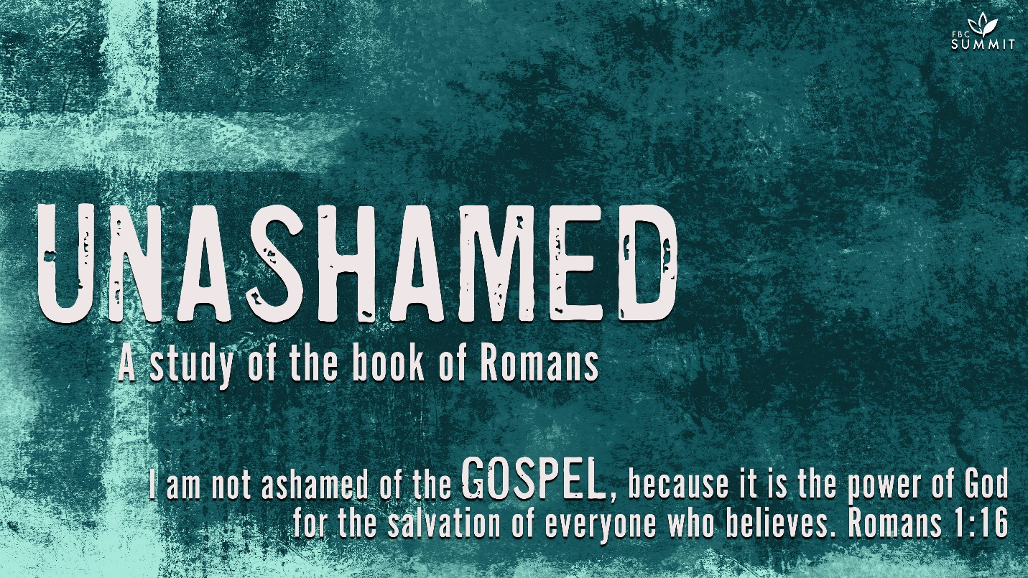

March 28, 2021
Romans 4:1-17

4 What then shall we say that Abraham, our forefather according to the flesh, discovered in this matter? ² If, in fact, Abraham was justified by works, he had something to boast about—but not before God. ³ What does Scripture say? “Abraham believed God, and it was credited to him as righteousness.”^{[a]}

⁴ Now to the one who works, wages are not credited as a gift but as an obligation. ⁵ However, to the one who does not work but trusts God who justifies the ungodly, their faith is credited as righteousness. ⁶ David says the same thing when he speaks of the blessedness of the one to whom God credits righteousness apart from works:

⁷ “Blessed are those whose transgressions are forgiven, whose sins are covered.
⁸ Blessed is the one whose sin the Lord will never count against them.”^{[b]}

⁹ Is this blessedness only for the circumcised, or also for the uncircumcised? We have been saying that Abraham’s faith was credited to him as righteousness. ¹⁰ Under what circumstances was it credited? Was it after he was circumcised, or before? It was not after, but before! ¹¹ And he received circumcision as a sign, a seal of the righteousness that he had by faith while he was still uncircumcised. So then, he is the father of all who believe but have not been circumcised, in order that righteousness might be credited to them. ¹² And he is then also the father of the circumcised who not only are circumcised but who also follow in the footsteps of the faith that our father Abraham had before he was circumcised.

¹³ It was not through the law that Abraham and his offspring received the promise that he would be heir of the world, but through the righteousness that comes by faith. ¹⁴ For if those who depend on the law are heirs, faith means nothing and the promise is worthless, ¹⁵ because the law brings wrath. And where there is no law there is no transgression.

¹⁶ Therefore, the promise comes by faith, so that it may be by grace and may be guaranteed to all Abraham’s offspring—not only to those who are of the law but also to those who have the faith of Abraham. He is the father of us all. ¹⁷ As it is written: “I have made you a father of many nations.”^{[c]} He is our father in the sight of God, in whom he believed—the God who gives life to the dead and calls into being things that were not.

COMMENTARY
4:1-2. Abraham was the father of the Hebrew nation (Gen 12:1-3). Jews commonly believed that Abraham kept the whole law before it was given on Mount Sinai (Gen 26:5), so he had something to brag about. Paul refutes this, showing that Abraham was justified by faith and had no grounds to boast.

4:3. Tradition must give way to the clear statements of the Scripture. Genesis 15:6 is the text that Paul cited.

4:4-5. Pay and gift are as different as works and faith. Paul describes God as having a set of books of the kind an accountant has. God imputed or credited righteousness to Abraham’s account because of his faith. To the one who does not work, but believes on Him who declares the ungodly to be righteous is a shocking expression. The Reformation focused on this passage. God saves the ungodly, sinners, and His enemies (5:5,8,10). Though Jews took Abraham to be a paragon of virtue, Paul declared that he was just a sinner saved by grace. He was justified by faith, just as any Christian is.

4:6-8. David, Israel’s greatest king, sang about the blessing that God gave him in the forgiveness of his deliberate sins—no works-righteousness here. David understood that, in God’s accounting ledger, his sins were wiped out and righteousness was inscribed in their place. Paul’s quotation of Ps 32:1-2 clarifies and explains Gen 15:6. Paul similarly links justification and the forgiveness of sin in his synagogue sermon recorded in Ac 13:38-39.

4:9-10. It might seem that God’s blessing was only for the circumcised since David’s psalm (Ps 32) was written by a Jew for the Jewish people. Paul returned to his key text in Gen 15:6 and showed that the crediting of righteousness to Abraham took place when he was uncircumcised, so God’s blessing is also for Gentiles who believe.

4:11. Circumcision was a sign and a seal. It marked out a man as part of the nation of Israel. It was also to be a seal of the righteousness a man had received by faith. The timing of Abraham’s circumcision enabled him to be the spiritual father and model for justification by faith to both circumcised Jews and uncircumcised Gentiles.

4:12. Abraham was the physical father of the Hebrew nation, but his greatest legacy was his example of faith. Jews and Gentiles alike can follow in the footsteps of Abraham’s faith.

4:13. The law demanded obedience and performance. If the law was violated, wrath resulted. The law was not a system of grace. God’s promise was one of grace. The promise to Abraham and his seed (Gal 3:16-18) was not through the law but through the righteousness that comes by faith.

4:14-15. If the inheritance of the promise came by legal obedience, then the way of faith is empty. Furthermore, no one would inherit the promise since no one could keep the law.

4:16-17. God’s promise is by faith, so that it may be guaranteed to both Jews and Gentiles who believe. If it were by law, no such guarantee would be possible. To make it certain, therefore, the promise was according to grace. Abraham was also promised to be the father of many nations. Abraham believed in the God who created everything from nothing and gives life to the dead.

MAIN POINT
Salvation is received by grace through faith, not by works of the law.

INTRODUCTION
As your group time begins, use this section to introduce the topic of discussion.

Have you ever received a gift that was difficult to accept because it was so valuable? Why did you feel unworthy of this gift?

Why do you think that accepting salvation by grace instead of works is so difficult?

Scripture describes Jesus Christ as a “stumbling block” to both Jews and Gentiles (1 Cor. 1:22). This is due, in part, to the fact that Christ offers sinners salvation freely by taking the punishment for their sin and giving them His righteousness. In other words, salvation must be received by faith, it can never be earned by human effort. This is difficult for many to accept because in our sin, we think too highly of ourselves—we deem ourselves capable of improving to such a degree that God must accept us. Scripture, however, teaches that the righteousness God requires is impossibly out of reach. We cannot earn God’s righteousness, it must be imputed to us. To “impute” is to attribute a quality to a person derived from another person. When we trust in Jesus, though we are sinners, God considers us as righteous as His own Son! How could there be better news than this? The best news in the world is that God has imputed to us the righteousness of Jesus Christ!

UNDERSTANDING
Unpack the biblical text to discover what the Scripture says or means about a particular topic.

- ASK A VOLUNTEER TO READ ROMANS 4:1-8.

What do you remember about Abraham’s story? What elements of his life remind you that he was a person just like us?

How does Abraham’s story exclude him from bragging?

What exactly did Abraham believe that led God to credit him with righteousness?

When God came to Abraham in Genesis 15 and promised that he and Sarah would have a son, Abraham believed and God counted him as a righteous man. We know that the seed that was promised was not simply Isaac, but the promise looked forward to the one through whom “all the nations of the earth” would be blessed (Gen. 22:18). Jesus said that in this promise, “Abraham was overjoyed that he would see My day; he saw it and rejoiced” (John 8:56). Abraham believed that God would send the Messiah, though he did not know when. Because of this faith, God credited Abraham with righteousness.

If we were to keep every law of God, would God then owe us salvation?

Who has ever kept all of the law?

How can God declare the ungodly to be righteous without being unjust or lying?

God does not simply declare someone righteous that is not. He credits faith to people as righteousness when that faith is placed in Jesus as their atoning sacrifice. Verses 6-8 reference Psalm 32:1-2. King David understood this declared righteousness because of the sacrificial system that foreshadowed the coming of the Messiah (Lev. 1:4). Jesus Christ is our sacrificial lamb. This is why John the Baptist exclaimed, “Look, the Lamb of God, who takes away the sin of the world!” (John 1:29).

- ASK A VOLUNTEER TO READ ROMANS 4:9-17.

Why is it important to point out that Abraham was credited with faith before he was circumcised?

What does it mean for Abraham to be the father of those who are not circumcised?

If the promise of salvation came through the law, how is faith made of no value and the promise made worthless?

Why does the law produce only wrath? What are the implications for us?

Paul pointed out that Abraham received the promise before he was circumcised to demonstrate that the promise could not be based on Abraham’s works. In other words, God was pleased when Abraham believed, and Abraham’s belief was demonstrated in his obedience. We are Abraham’s children because we believe in the promises of God for salvation as Abraham did. Abraham’s obedience was not because he wanted to earn the promise; he already had it! Instead, Abraham’s faithful work flowed from his joy in receiving the promise. Abraham’s children do not obey to earn salvation; they obey because of the joy of having salvation.

The law demanded obedience and performance. If the law was violated, wrath resulted. The law was not a system of grace. God’s promise was one of grace. The promise to Abraham and his seed (Gal. 3:16-18) was not through the law, but through the righteousness that comes by faith. If the inheritance of the promise came by legal obedience, then the way of faith is empty. Furthermore, no one would inherit the promise since no one could keep the law.

NEXT STEPS
Help your group identify how the truths from the Scripture passage apply directly to their lives.

How freeing is it to realize that we are credited with Christ’s righteousness and do not have to depend on our own works for salvation? How does that change things for you?
Who can you think of that needs to hear the good news that righteousness is about your faith and not your works?

What is stopping you from sharing the good news with them?

PRAYER
As you close your small group time, thank God that He has given Jesus as our Savior, and that we can be counted among Abraham’s children because of Jesus’ love for us. Ask the Father to teach us to love grace more, that we might learn to be more gracious to others. Finally, ask the Father to help us share the good news freely, as it has been freely shared with us.

